|  |
| --- |
| **Campus  >> How To Get To IITB** |
| |  | | --- | | **HOW TO GET TO IITB** | | IIT Bombay is located at Powai, which is an eastern suburb in the North-Eastern part of Mumbai.  [Mumbai](http://www.iitb.ac.in/campus/howto/railmap.html) is in the form of a long narrow island, almost a peninsula, thrusting south wards into the Arabian Sea. It can be broadly divided into four zones.   South Bombay (Colaba, CST,Fort, Chruchgate, Nariman Point etc.)  Central Bombay (Dadar, Bombay Central, Worli etc)  The Western suburbs (Bandra, Juhu, Andheri, Borivali etc)  The Eastern Suburbs(Kurla, Chembur, Ghatkopar, Mulund, Kanjur Marg, Vikhroli etc.)   There is also New Bombay (Vashi, Turbhe etc.) across Thane Creek on the mainland.   **Public Transport** Mumbai has one of the most efficient and reliable public transport network. One can travel by Autorickshaws / Taxis to reach IIT from the nearest stations(Autorickshaws, however do not go further south than Sion and Bandra). For longer distance, you can use either the BEST Bus Network or the Mumbai [Local train System.](http://www.iitb.ac.in/campus/howto/touristmap.html)  **Suburban Railway Transport**  Those coming by Central Railway Suburban train will have to get down at Kanjur Marg, Vikhroli or Ghatkopar which are the nearest stations from IITB. If you are coming by the Western Railway Suburban train you will have to get down at Andheri, Bandra, Goregoan or Malad. We give below the Road Network to reach IITB along with the approximate [Bus/ Autorickshaws/ Taxi fare](http://www.iitb.ac.in/campus/howto/howtoget.html#FARE). (Click [here](http://www.iitb.ac.in/campus/howto/howtoget.html#map) to see the Road companion for IITB ) | | |  | | --- | | http://www.iitb.ac.in/campus/howto/roadmap.jpg | | | |  |  |  |  |  | | --- | --- | --- | --- | --- | | NAME OF PLACE | BUS NUMBERS | APPROX.BUS FARE | APPROX.AUTO FARE | APPROX.TAXI FARE | | Mulund(W) | 307, 346, 425, 396, 398, 460, 422, 424, 461 | Rs.10.00 | Rs.70.00 | Rs.150.00 | | Bhandup(W) | SAME AS ABOVE | Rs.7.00 | Rs.40.00 | ------ | | Kanjur Marg(W) | SAME AS ABOVE | Rs.5.00 | Rs.20.00 | ------ | | Vikhroli(W) | 392,382,337 | Rs.6.00 | Rs.30.00 | ------ | | Ghatkopar(W) | 392,382.337 | Rs.10.00 | Rs.50.00 | ------ | | Borivali(E) | 461, 398, L1 | Rs.18.00 | Rs.70.00 | Rs.180.00 | | Goregaon(E) | 460,489,424 | Rs.15.00 | Rs.70.00 | ------ | | Jogeshwari(E) | 461,445 | Rs.12.00 | Rs.60.00 | ------ | | **Andheri(E)** | 396,336,392,307 | Rs.9.00 | Rs.65.00 | Rs.75.00 | | Bandra(E) | 422,424 | Rs.15.00 | Rs.100.00 | Rs.125.00 | | **Kurla** | ------- | **-------** | **Rs.70.00** | **Rs.130.00** | | **Dadar** | ------ | ------ | ------ | **Rs.130.00** | | **CST** | ------ | ------ | ------ | Rs.225.00 | | Mumbai Central | ------ | ------ | ------ | Rs.230.00 | | Sahar Air Port | ------ | ----- | ------ | Rs.100.00 | | Santacruz | ------ | ------ | ------ | Rs.150.00 | | | **Stations for Through Trains Coming to Mumbai** | | |  |  | | --- | --- | | Central Railway | CST, Dadar, Kurla, Thane. | | Western Railway | Mumbai Central, Dadar, Bandra, Andheri,Borivali, Kurla | | | There is a terminus at Kurla where some Central as well as Western Railway Trains terminate. There is no convenient bus route from Kurla terminus. An autorickshaw is the best option. However it would be more economical to take a suburban train from kurla to Kanjur Marg and then take an Auto.   **AIR PORTS**   International flights land at Sahar Airport which is about 7 kms from IIT. The Domestic Airport- SantaCruz is about 10 kms. Pre paid taxis are available at the Airports. Autorickshaws are also available for IIT. | |

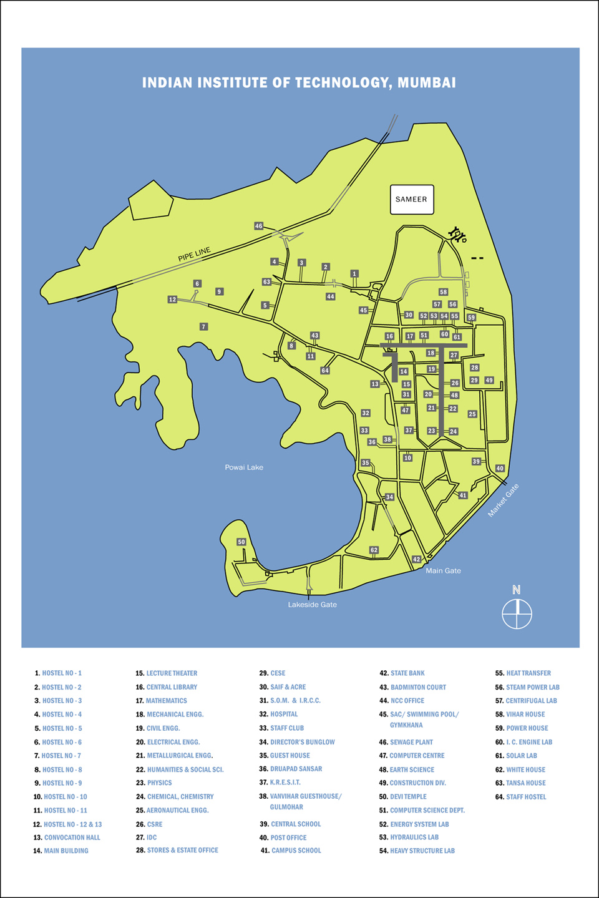

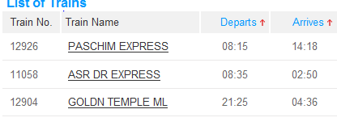

* PASCHIM
  + 31 HRS, 1802km
  + Rs.1607
* ASR DR EXPRESS
  + Rs 1655
  + 1993km
* GOLDEN TEMPLE MAIL
  + rs1630
  + 1861km
  + 31hrs



